**Experiment: 05**

**Date: 20.04.2022**

**Title: LP Solution with Excel Solver.**

**Question:**

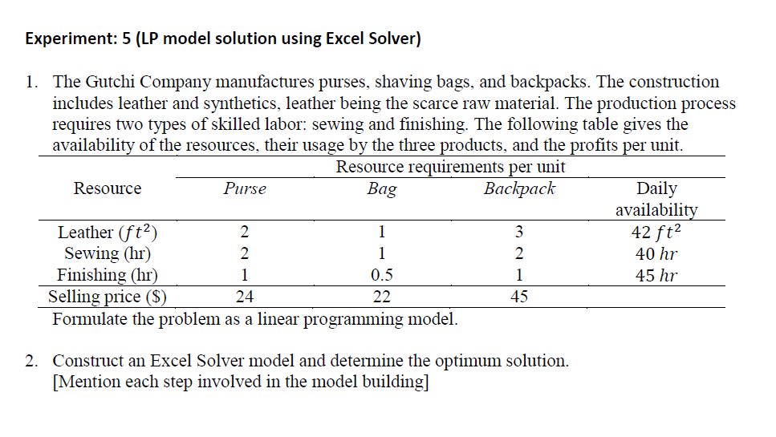

**Answer:**

**1.**

**The given problem is formulated as a linear programming problem as shown below.**

**The decision that needs to be taken here is how many units of each product to be produced.**

**Let 1, 2,3 represent the products Purse, Bag and Backpack respectively.**

**Therefore, the decision variables can be defined as:**

$$x_{1}=the number of units of Purse produced$$

$$x_{2}=the number of units of Bag produced$$

$$x_{3}=the number of units of Backpack produced$$

**The objective is to maximize total income. The total income is the sum of the product of the unit price and the respective number of units for all the products.**

**Therefore, the objective function is:**

$$Maximize z={24x}_{1}+{22x}_{2}+{45x}_{3}$$

**The constraints can be defined as follows:**

1. **The total leather used cannot be more than the available leather.**
$${2x}_{1}+{1x}_{2}+{3x}_{3}≤42 ft^{2}$$

2. **The total sewing hours used cannot be more than the available sewing hours.**
$${2x}_{1}+{1x}_{2}+{2x}_{3}≤40 hr$$

3. **The total finishing hours used cannot be more than the available finishing hours.**
$${1x}_{1}+{0.5x}_{2}+{1x}_{3}≤45 hr$$

4. **The decision variables are non-negative ,**

$$x_{1},x_{2},x_{3}≥0$$

**The required mathematical formulation of the given problem :**

$$Maximize z={24x}_{1}+{22x}_{2}+{45x}_{3}$$

**Subject To ,**

$${2x}_{1}+{1x}_{2}+{3x}_{3}≤42$$

$${2x}_{1}+{1x}_{2}+{2x}_{3}≤40$$

$${1x}_{1}+{0.5x}_{2}+{1x}_{3}≤45$$

$$x_{1},x_{2},x_{3}≥0$$

**2.** **LP Solution with Excel Solver:**

In Excel Solver, the spreadsheet is the input and output medium for the LP. We use the following steps to formulate the following model in Excel:

LP model:

$$Maximize z={24x}_{1}+{22x}_{2}+{45x}_{3}$$

**Subject To ,**

$${2x}_{1}+{1x}_{2}+{3x}_{3}≤42$$

$${2x}_{1}+{1x}_{2}+{2x}_{3}≤40$$

$${1x}_{1}+{0.5x}_{2}+{1x}_{3}≤45$$

$$x_{1},x_{2},x_{3}≥0$$

**Step 1.:**

* Constraints data are entered first in the worksheet.

Cell B5:D5 shows the coefficient of the variables for the first constraint. Similarly, B6:D6 and B7:D7 shows the coefficient of the variables for the second and third constraints, respectively. B9:D9 shows the profit per unit of the products. Cell E5:E7 indicates the type of the constraints. Cell F5:F7 indicates the right-hand side values (resource amount) of the constraints.

**Step 2. :**

* Cell locations for decision variables are specified. Cells B13,C13 and D13 are earmarked for decision variables.

**Step 3.:**

* Objective function data of maximization is entered below the constraints data, and a formula for computing the objective function is created in a cell. Cell B14 would give the final value of maximum profit earned, i.e. the objective function. For its calculation, a formula has to be created which is the sum of product of profit per unit from each product and the number of units sold. Hence the formula for it is **Cell B13: = B9*B13 + C9*C13 + D9*D13** OR one can use SUMPRODUCT function available in the excel spreadsheet as the following

**Cell B14:=SUMPRODUCT(B9:D9,$B$13:$D$13).**

**Step 4. :**

* The formula for computing the left side of the constraints are formulated in **Cell** **B15:B17**. The formulas are as follows:

**Cell B15:=SUMPRODUCT(B5:D5,$B$13:$D$13),**

**Cell B16:=SUMPRODUCT(B6:D6,$B$13:$D$13),**

**Cell B17:=SUMPRODUCT(B7:D7,$B$13:$D$13)**

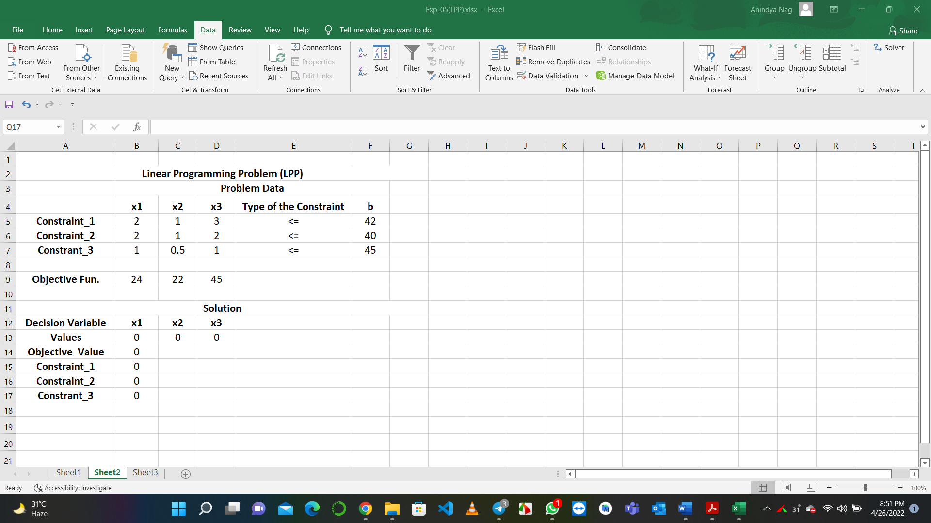

**In Microsoft Excel, after entering entire linear programming data in the worksheet, the following steps would lead to a solution:**

**Step 1. :**

* Select **Data** menu in the toolbar.

**Step 2.:**

* In Data menu, select **Solver** application.

**Step 3.** **:**

* Open Solver application. In Solver parameters dialog box Enter **$B$14** in set target cell. Select purpose of max (depending on the type of the objective). Enter **$B$13:$D$13** in by changing cell box. To enter constraint equations, click on Add button.

**Step 4. :**

* When the Add constraint dialog box opens, it would have three boxes: first, cell reference; second, inequalities of ≤ and lastly, constraint box. For first constraint, enter **$B$15** in cell reference box; enter inequality of **≤** and **$F$5** in the constraint box. Then click on Add to add more constraints. To include the other constraints use the similar procedure. After entering all constraints, click **OK**.

**Step 5.:**

* Now choose Options. Select Assume Non-Negative and Assume Linear Model (in **MS Excel 2007**). In **Excel 2010** onwards, select Make Unconstraint Variables Non-negative and select Simplex LP from the dropdown menu of Select a Solving Method. Click **OK**.

**Step 6. :**

* When Solver parameters dialog box appear, click on **Solve**.

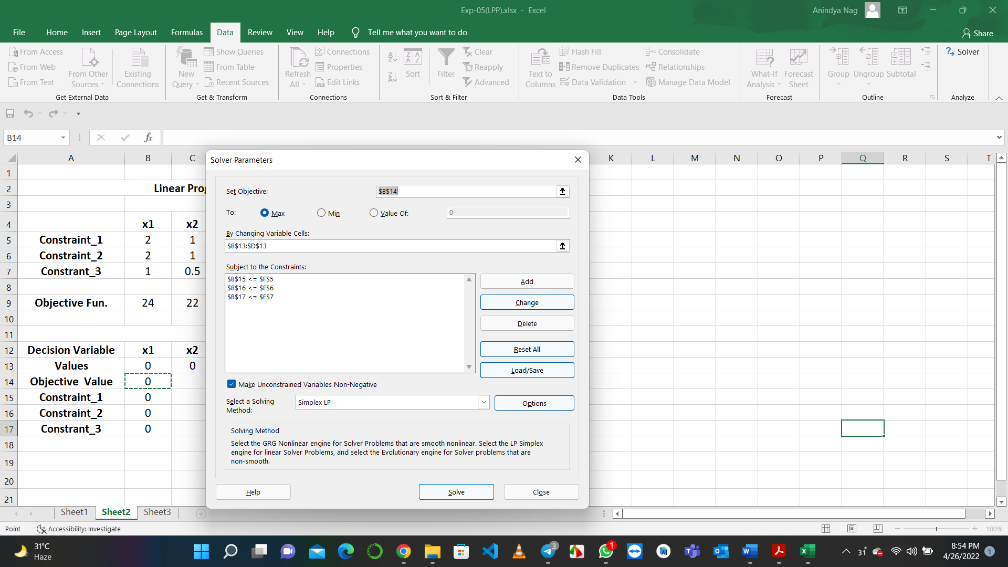

**Step 7.:**

* Finally, when final solution appears on the worksheet, select Keep Solver Solution and click **OK**.

**Step 8. :**

* If a problem has no feasible solution, Solver will issue the explicit message “Solver could not find a feasible solution”. If the optimal objective value is unbounded (not finite), Solver will issue the somewhat ambiguous message “The Set Cell values do not converge”. In either case, the message indicates that there is something wrong with the formulation of the model.

**Output:**

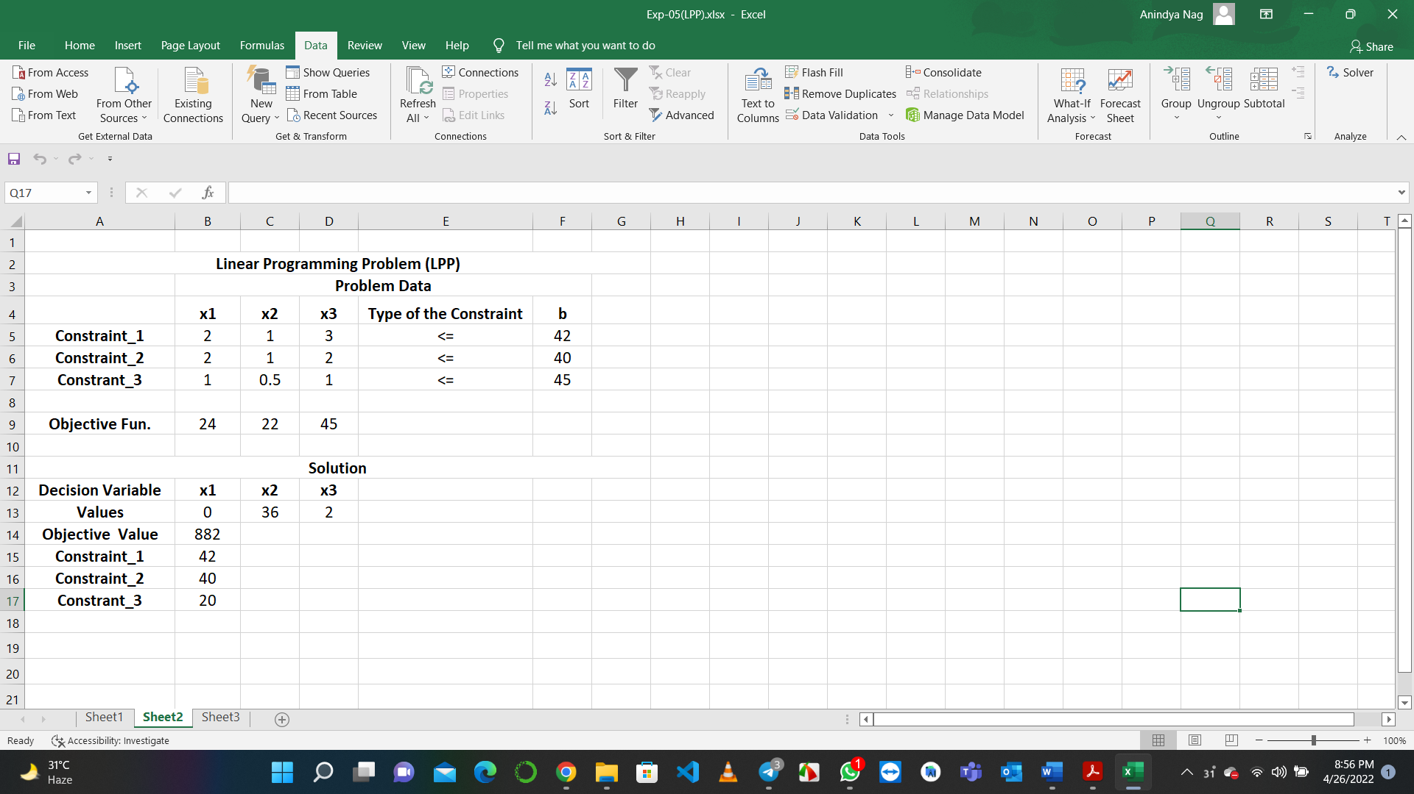

**Conclusion:**

**Hence,**

**The Optimal Solution is**

$$z_{max} = 882$$

**And**

**The corresponding solution is**

$$The number of units of Purse produced=x_{1}=0$$

$$The number of units of Bag produced=x_{2}=36$$

$$The number of units of Backpack produced=x_{3}=2$$